Ulvi Bajarani
SID 20539914
CSCI 6345 – Advanced Computer Networks
Summer II
Assignment 2
The file sharing with Samba between Windows and Ubuntu
1) The installation process of Samba.
First, both sudo apt update and sudo apt install samba should be executed. Due to the fact that all had been already updated, the author executed only sudo apt install samba:
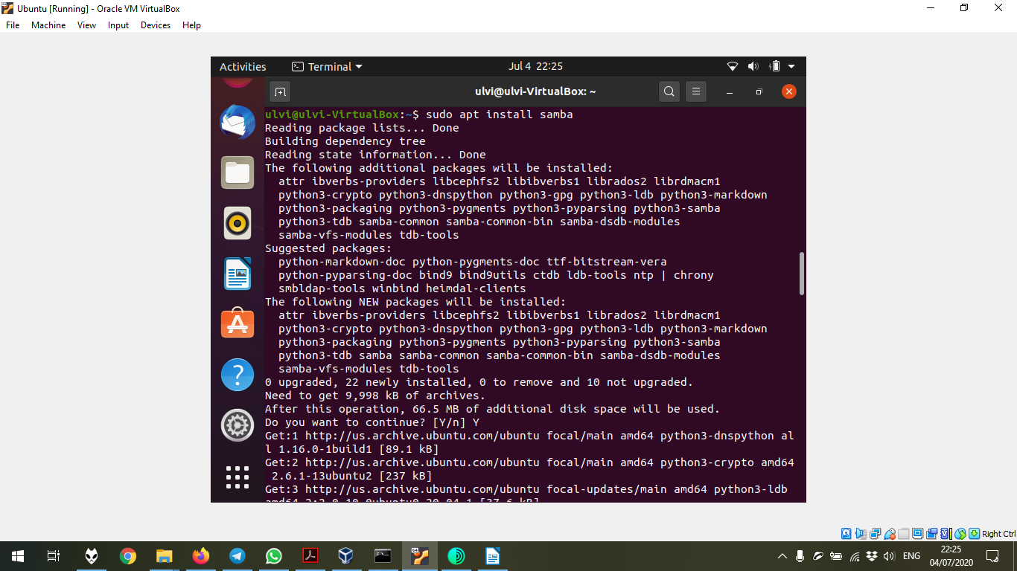

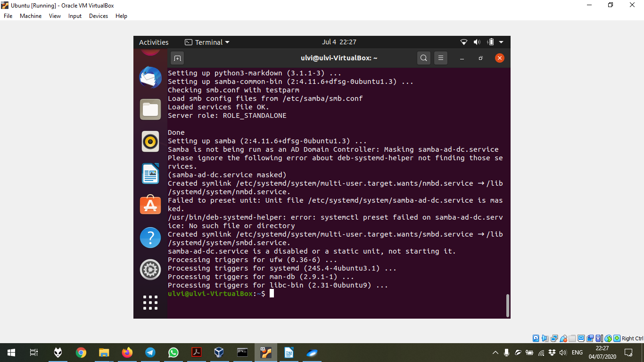
The end of the installation process:
To check if the Samba is installed, the command whereis samba is executed:
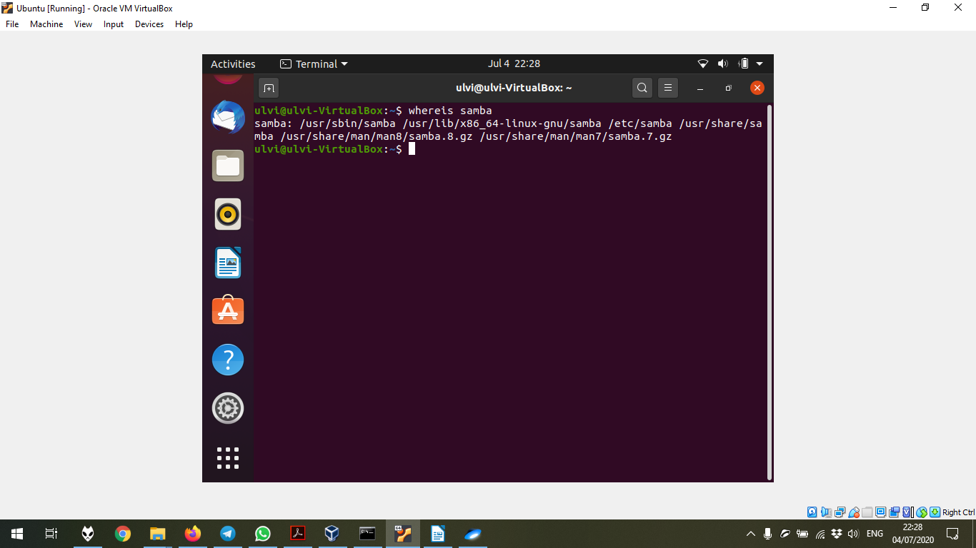
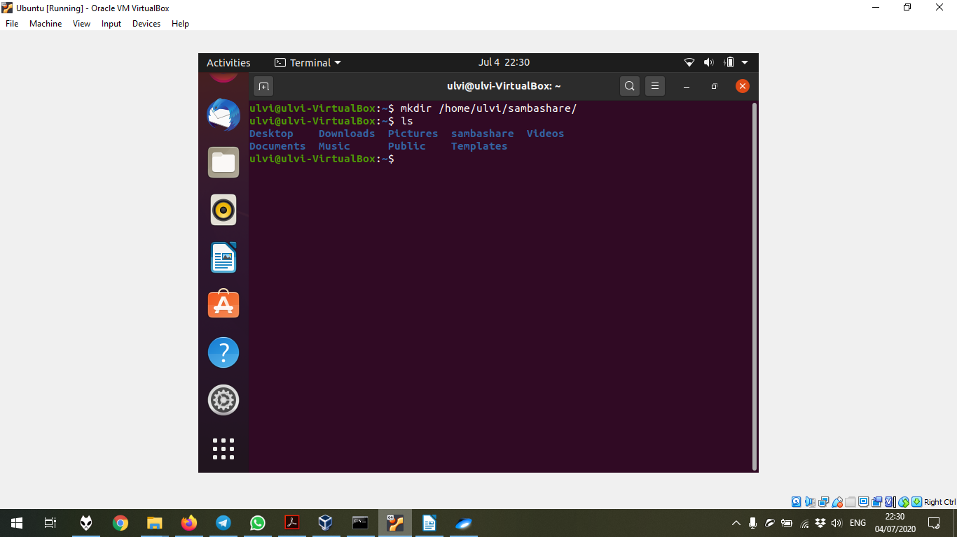
2) The creation of the folder to share. It was done by mkdir /home/<username>/sambashare/ command. In the case of the author, mkdir /home/ulvi/sambashare/:

It is important to add the information about the folder to the configuration file. After executing sudo nano /etc/samba/smb.conf command, the words below should be added at the bottom of the file and the file should be saved:
[sambashare]
comment = Samba on Ubuntu
path = /home/<username>/sambashare // in my case, /home/ulvi/sambashare/
read only = no
browsable = yes
Where
comment – The description of the share.
path – The directory of our share.
read only – The read-only permission. If it is yes, the share couldn’t be modified. We put no to be able to modify.
browsable – The permission to view the file in the Ubuntu file system. If it is “yes”, it might be seen under “Network” share.
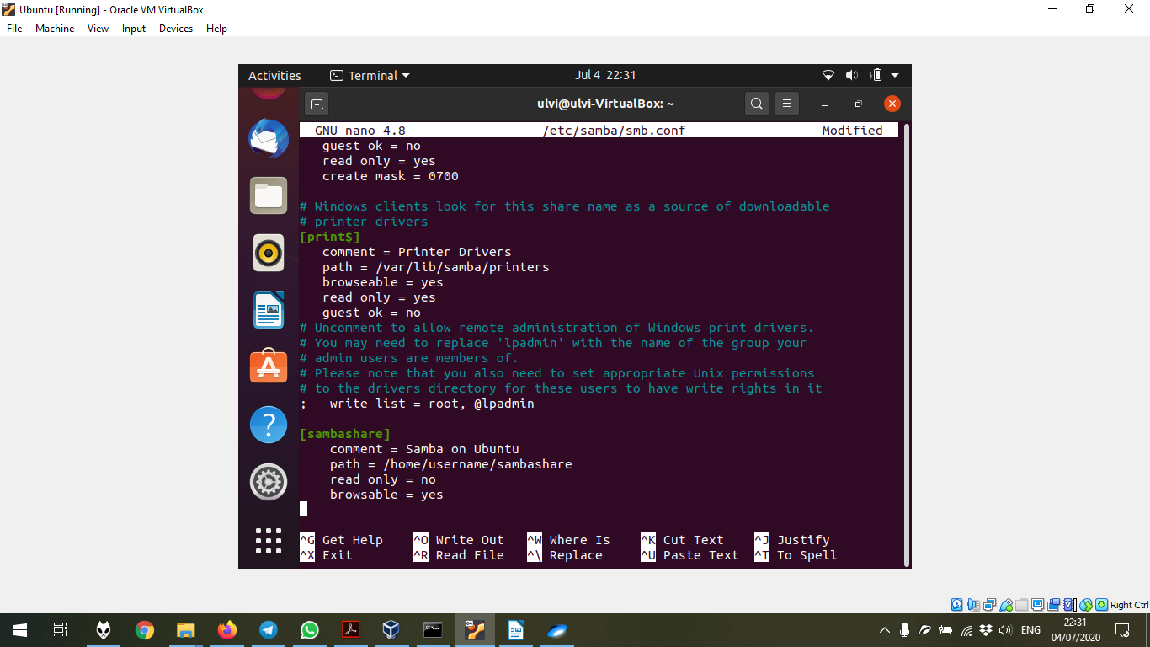

After this, the service should be restarted by sudo service smbd restart command. Then, the firewall rule should be added by sudo ufw allow samba command. In the final, the user is created by sudo smbpasswd -a <username> command (in my case, sudo smbpasswd -a ulvi):
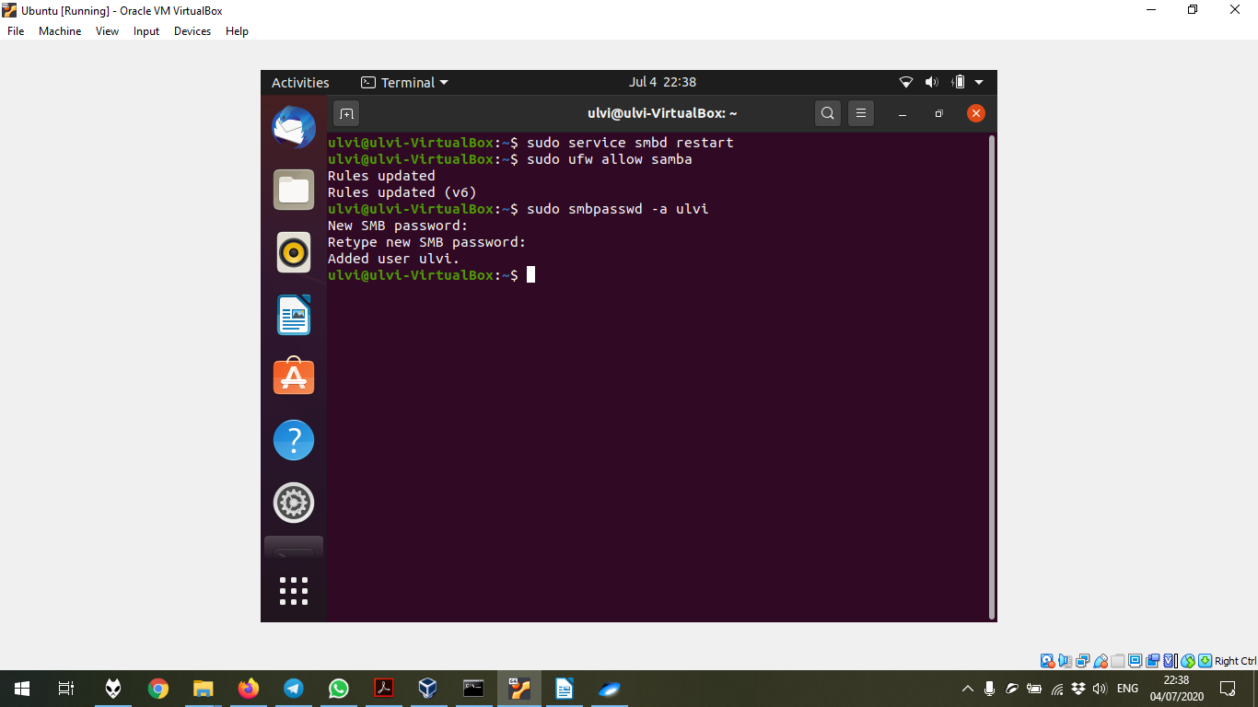
3) Now, we can check if it works. In Windows, (in my case, Windows 10), we open Run by Win+R, and type \\<your-ip-address-to-ubuntu>\<your-share-folder> (in my case, \\129.113.42.27\sambashare)
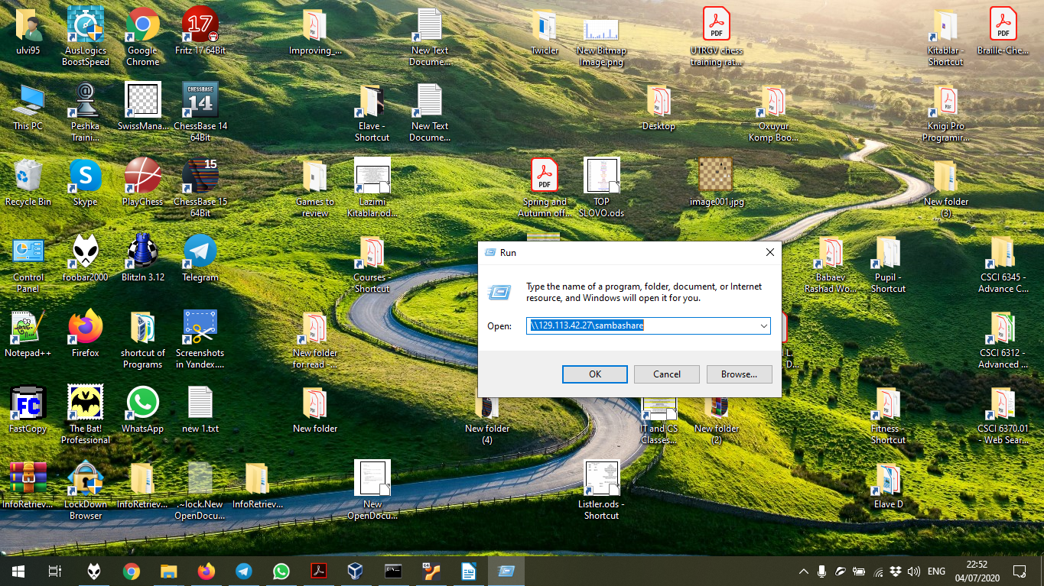

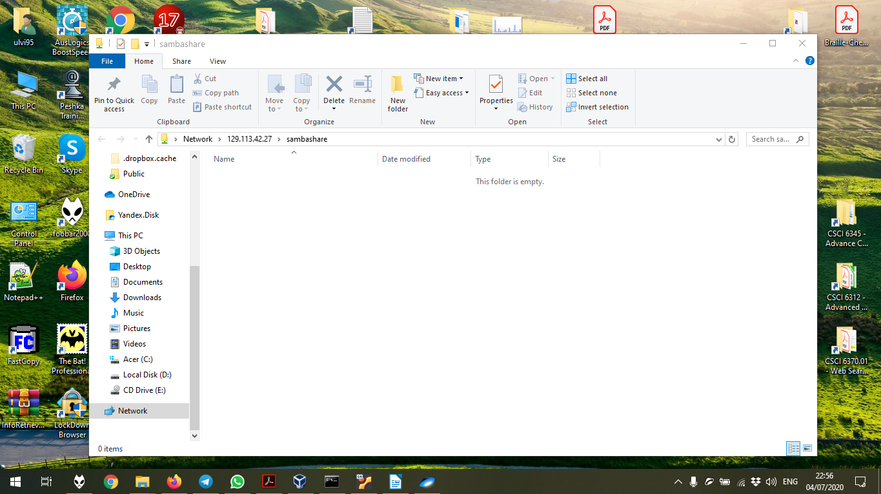
In the first open, it asks your username and password. It is important to use another account, since it provides your UTRGV e-mail by default. In the next times, it doesn’t ask the authorization. Unfortunately, the author hadn’t took the screenshot of the authorization, so the next screenshot belongs to the next executions:

The creation of the file new2.txt
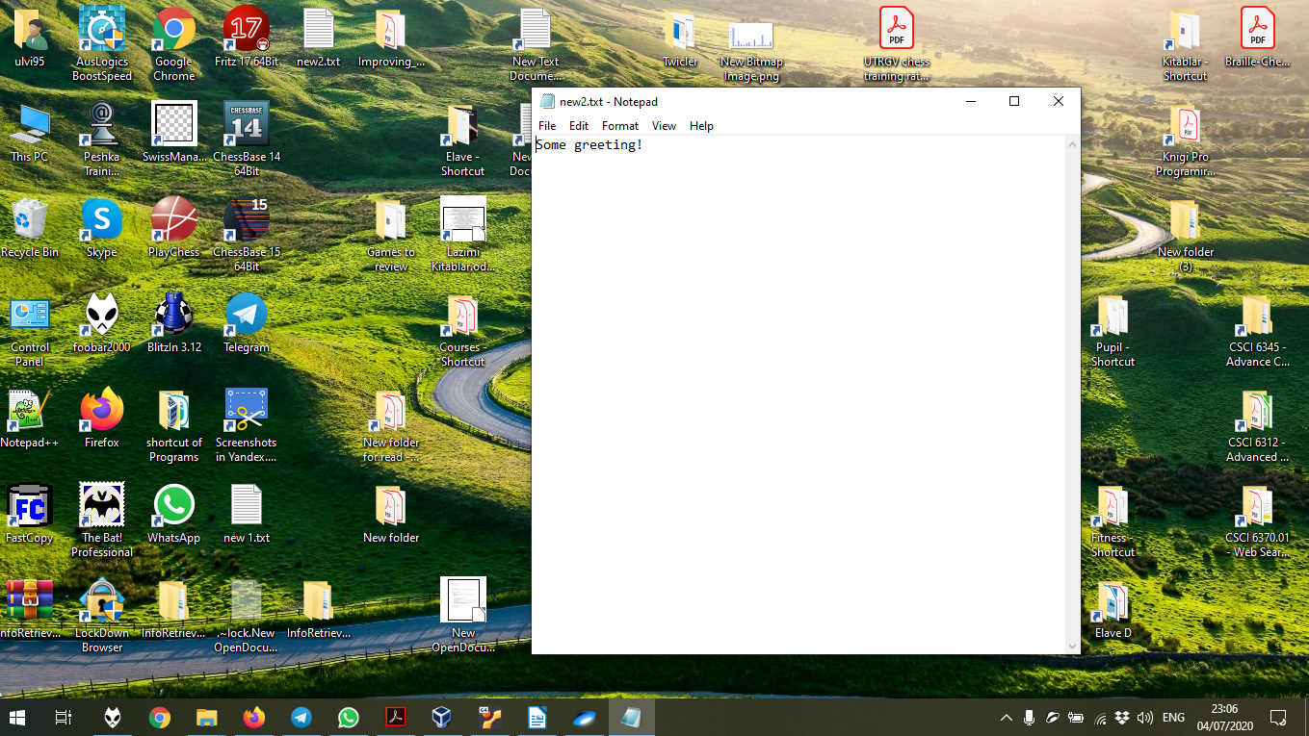

The copying of new2.txt

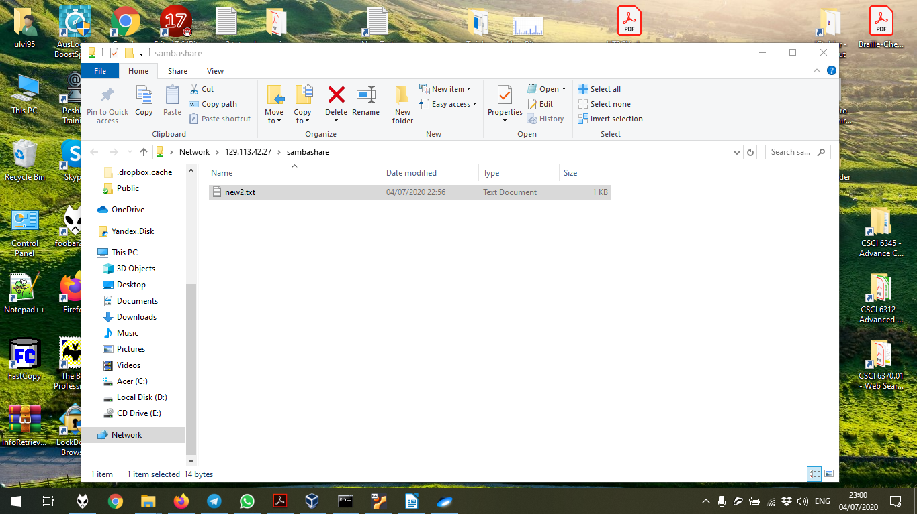

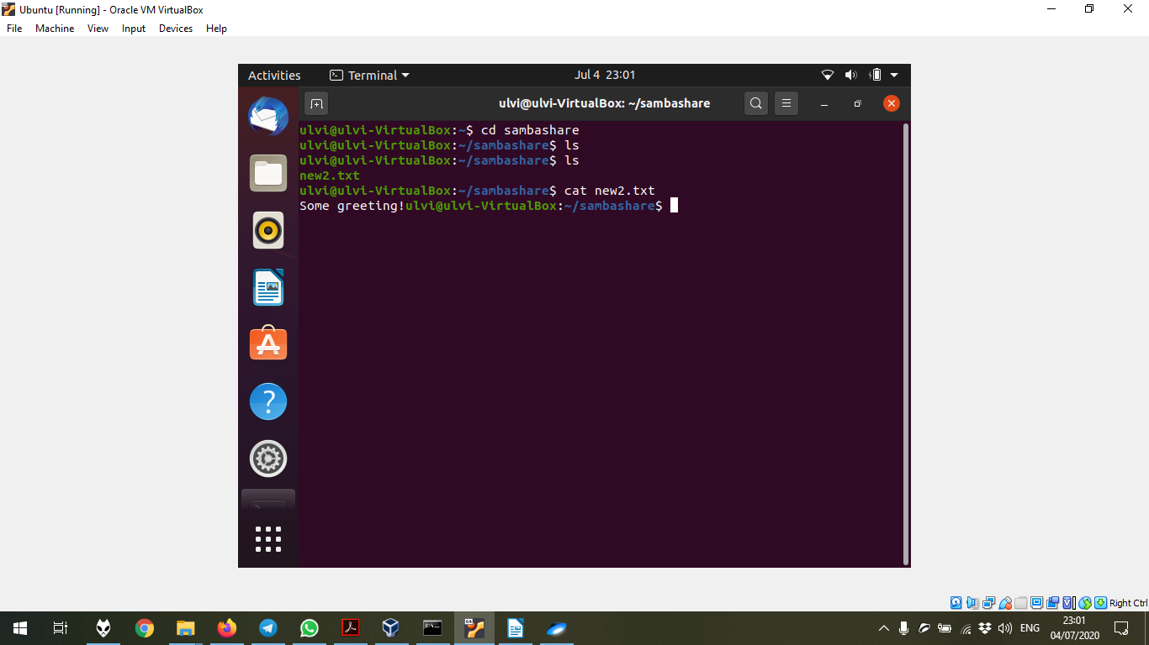
The test of the share folder. It might be seen that before the copy, the folder was empty, but after the copying, the file new2.txt is available to see and even to execute:

The creation the file new1.txt in Ubuntu to check if it might be seen in Windows 10. The file is empty, because it is created by the touch command:
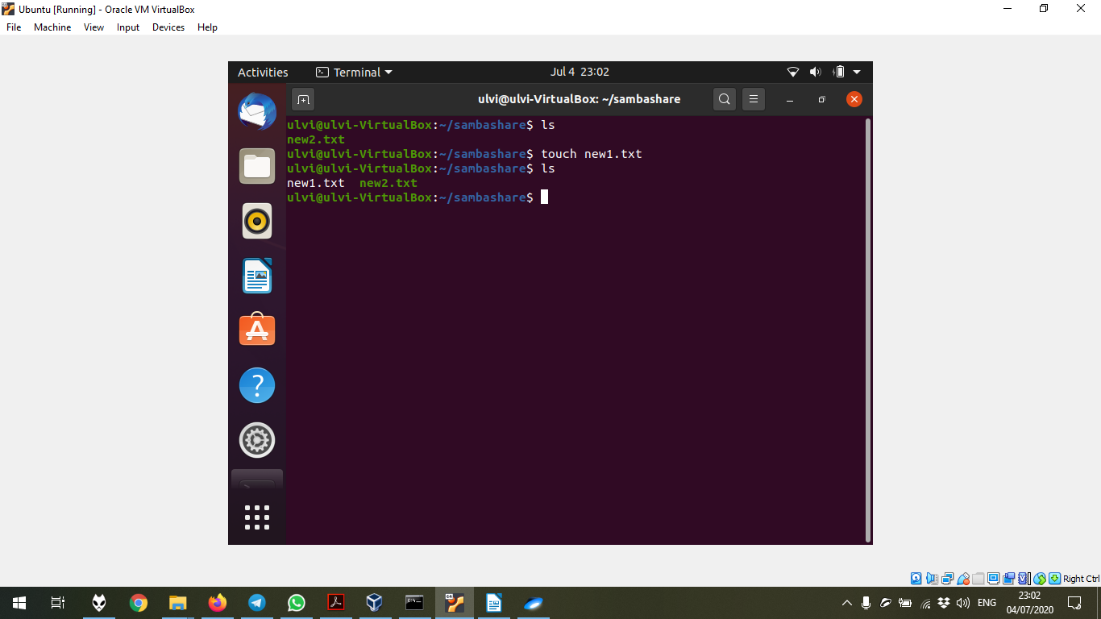
The checking in Windows 10. It can be seen, and it is 0KB, since it is empty:



